C:\Users\NerveDigitals\Desktop\SEO Content\Images\frontline-logo-OK-01-e1566916661350.png

**SITE VISIT CONFIRMATION LETTER**

Dear Mr. Sheikh Muhammad Zia-ud-Din,

It is an honor with pleasure for us to inform you that your visit at HOORIYA RESIDENCY’S SITE OFFICE has been confirmed on the following schedule:

*Monday, 7 October, 2019 at *

We look forward to having the opportunity to serve you at the above mentioned schedule.

Google Map Link for the site office: *GOOGLE MAP’S LOCATION LINK*

Thank you.

Regards,

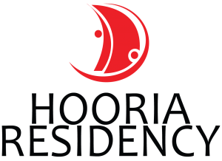

C:\Users\NerveDigitals\Desktop\SEO Content\Images\frontline-logo-OK-01-e1566916661350.png

Contact: *(021) 12345678*